**PROJECT SCOPE**

**Project-setup**

To sell Smart Agri System, we need to sell an iOS app through Apple's App Store, the first thing you’ll need to do is sign up for an Apple Developer Account. Getting the proper certificates and provisioning profiles can be a little complicated so we set aside time to guide you through that process to make sure all the details are taken care of.

**Use-case scenarios**

Upfront planning is key when it comes to designing successful, compelling mobile app. Our experience with apps allows us to map out the most efficient path to accomplishing the goals of your project. Our first goal in this phase is to articulate all the desired functionality and outline exactly how the app will work.

The purpose of use-case scenarios is to defining user goals, what they want to accomplish, and the best way to present the information they need. We'll also define:

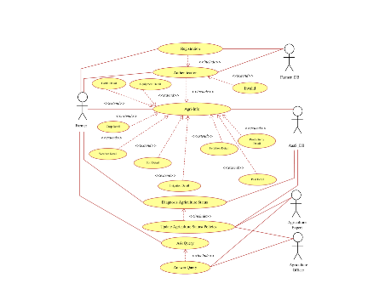

**Target Customer**

* What they want from the Smart Agri for themselves/ bussinesses /clients.
* Which tools we can provide to meet their needs.
* Which action(s) they want to take or goals will they want to accomplish with Smart Agri.
* How can we maximize functionality within the app to expedite tasks
* What content will be needed.  
  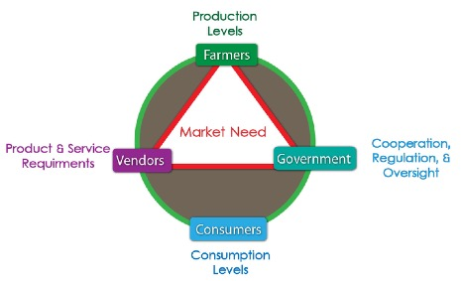

**Sitemap**

Once we know who will use our product and how, we'll create a written outline of functionality and workflow. The sitemap describes in written format what kind of functions need to be present and how to categorize that information.

Creating a sitemap also helps us think specifically about what type of content needs to be generated for the app (i.e. imagery, function name, function description, etc.)

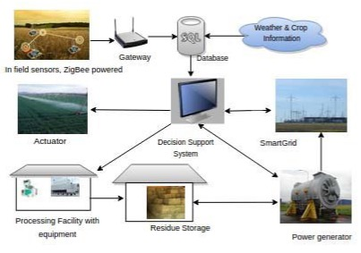

**Content**

For this step in the process, any additional content you want to have in the product (included Embedded System and Mobile App) must be provided. Having final content will help us iron out any unknowns we might encounter in designing the flow of the app and presenting it to the user.

**Wireframes - Visualization**

A visual representation of the sitemap is created in the wireframing phase that includes all of the content provided.  Wireframes are a navigable prototype of how the application will work.

**Development**

The application development phase of iPhone development is a quiet time in the project as far as client feedback. Unlike website development where there may be visuals to approve or interaction regarding content, all of this work is done before entering the app development phase. That's why it is so important to spend quality time in the planning and information architecture phases of the project.

We like to prepare clients for the fact back and forth communication will be minimal until the Alpha Test version is ready for distribution. However, during Alpha and Beta testing it will be important for us to test the app. Believe it or not, during this time our goal is to purposely try to break the app as it's better to work out all of the bugs internally than have customers point them out for us!



**Launch**

To protect customers and to make sure there are no security vulnerabilities Apple requires a review of all apps before they are accepted to the App Store. This is a straightforward and standard practice and usually only takes about a week. You submit the app in your company's name and pay a small fee. In the event there is any feedback from Apple, we will deal with those issues for you to get the app finalized and ready for distribution.